Chapter 14, Solution 15.

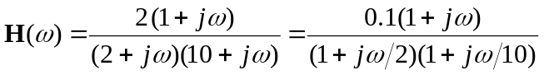

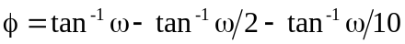

The magnitude and phase plots are shown below.
f
-45°
45°
w
100
1
10
0.1
-90°
90°
H_{dB}
-20
20

w
100
1
10
0.1
-40
40

